[Date]
Dear [insert neighbor’s name],

I’m your neighbor [insert your name] at [address], and I would love to talk with you about good outdoor lighting. I notice that you have installed outdoor lights on your property, and I applaud your desire to help improve our neighborhood.

You may not have realized that some of your lights are a bit too bright and shine in [pick areas as they apply: our bedroom window, the backyard, into our house etc.] and interfere with our [sleep, hobbies, view of the sky, etc.]. I don’t wish to tell you what to do with your home, but I’m hoping we can openly discuss this and come to a compromise that fulfills and respects everyone’s needs. Please understand I’m not asking you to remove the lights, but perhaps make subtle changes that will work for everyone.

One idea would be redirecting the light by shielding the fixtures so that they are even more effective. Unshielded lamps create dangerous glare — this glare causes harsh shadows which can blind you to real, hidden hazards such as unwanted visitors (see pictures below). On the other hand, shielded lighting provides real security (not just the illusion of security) which I think we both want for our homes. As an extra benefit, shielding a lamp usually involves a lower wattage bulb, which would be a money-saver on your electric bill.

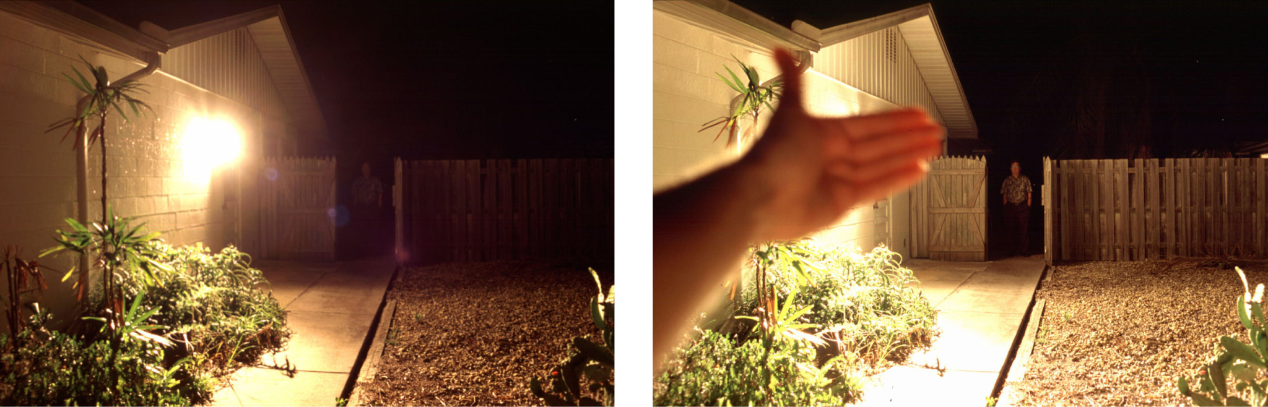

There are several other ways to improve lighting, save money, and still be safe. One is using motion sensors, which alert you if someone is in your yard after dark, and also reduce your electric bills by keeping the lights off when not needed. Timers are another way to save money, since they can automatically turn off your outdoor lights when you go to bed.

Thank you so much for your time and understanding! I would love to talk with you about how I can help, and how lighting changes can benefit your safety, budget, and the night sky.

Sincerely,
[your name]
[contact info]

